FocusFlow / ADHD Scheduler

V1 Requirements Specification
Human-readable product requirements for current and planned V1 behavior, with implementation status separated from future work.

Source status and interpretation rules
Source | Use in these documents | Status
Repo AGENTS.md, README files, package pubspecs, completed plans, ADRs, source files | Primary source of truth for current architecture, tooling, package layout, implemented state, and quality gates. | Current / authoritative
Completed Plans: V1 requirements traceability, public API baseline, Blocks 01-08, 11-14, 19-29, UI Plan 1 | Used to map features, acceptance criteria, APIs, and current verification history. | Current curated documentation
Human Documentation: Overall App Design Spec and UX flow deck | Used for human-facing product intent and UX requirements. | Product intent / design reference
Older recreation handoff mentioning MongoDB | Only used as historical continuity where it does not conflict with repo truth. | Superseded by SQLite-first repo

Accuracy rule: SQLite-first local persistence, Drift adapters, Flutter desktop UI, and the completed-plan archive are treated as current. MongoDB-era notes are explicitly not used as current implementation guidance.

Plain-language product intent
FocusFlow is intended to reduce the executive-function cost of planning a day. It treats plan changes as normal: flexible work can move, required commitments stay visible, unavailable time is protected, and unscheduled work remains safe in Backlog instead of becoming a failure bucket.
The app is not a generic checklist. Its value is a scheduling system that can preserve intent when the day breaks: capture work quickly, place it automatically when enough information exists, move flexible work around protected time, log what actually happened, and keep the user oriented without guilt language.

Audience and operating assumptions
Assumption | V1 requirement
Primary device | Desktop-first Flutter app.
Primary surfaces | Today and Backlog only.
Planning style | Capture first; structure later when needed.
Persistence | Local-first SQLite.
Tone | Calm, specific, non-blaming language: missed, pushed, backlog, archived.
Not V1 | Week/month views, reports/dashboard, sync, drag-and-drop, Shield/Recovery, visible history panel, dependencies/context tags.

Current UI reference
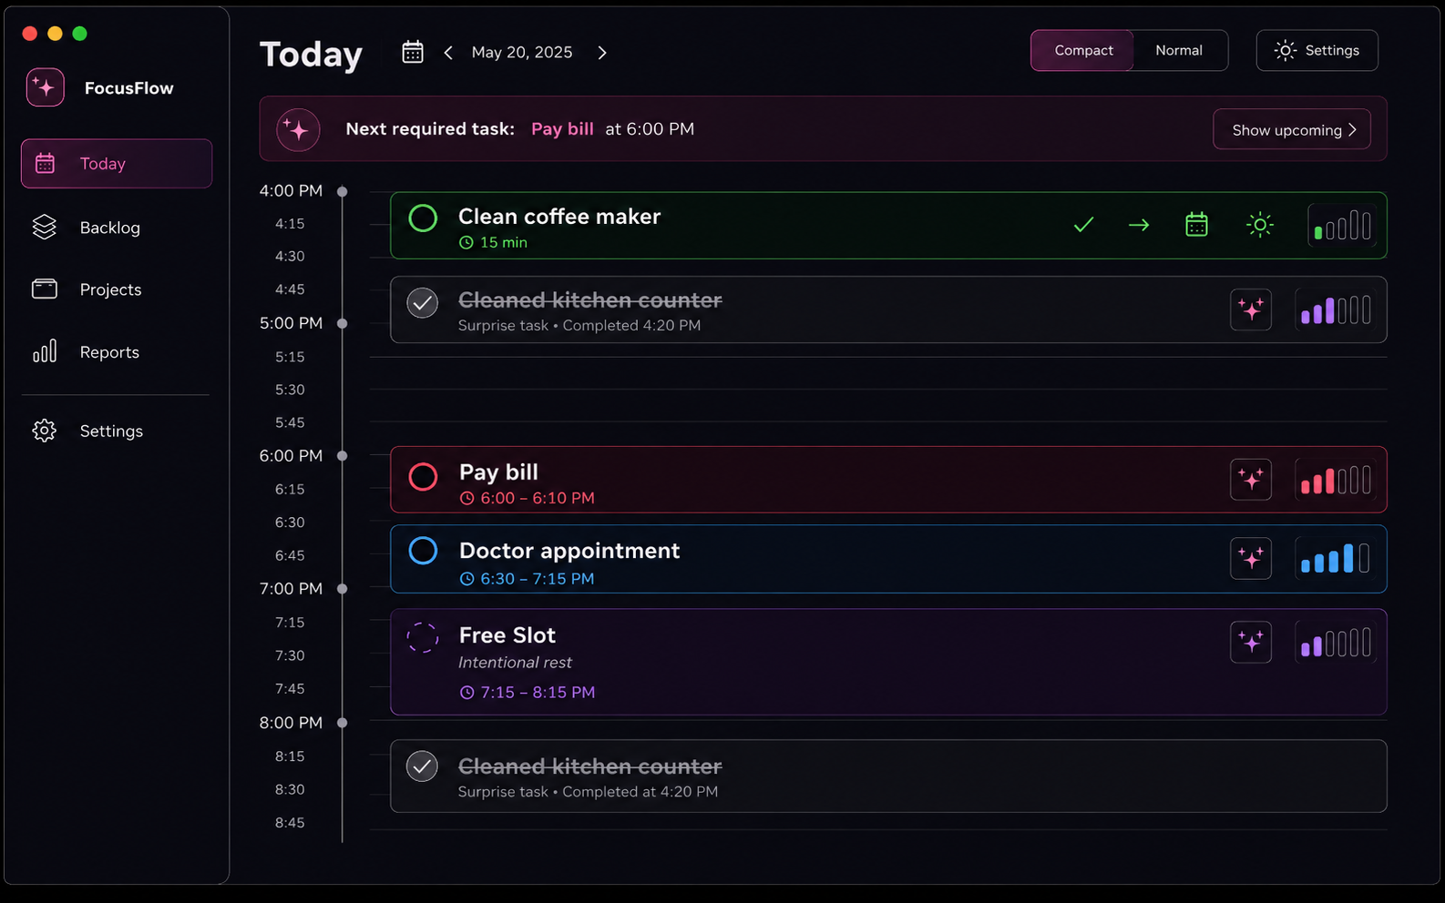
Current implemented UI slice: compact Today timeline mockup with seeded scheduler-backed data.
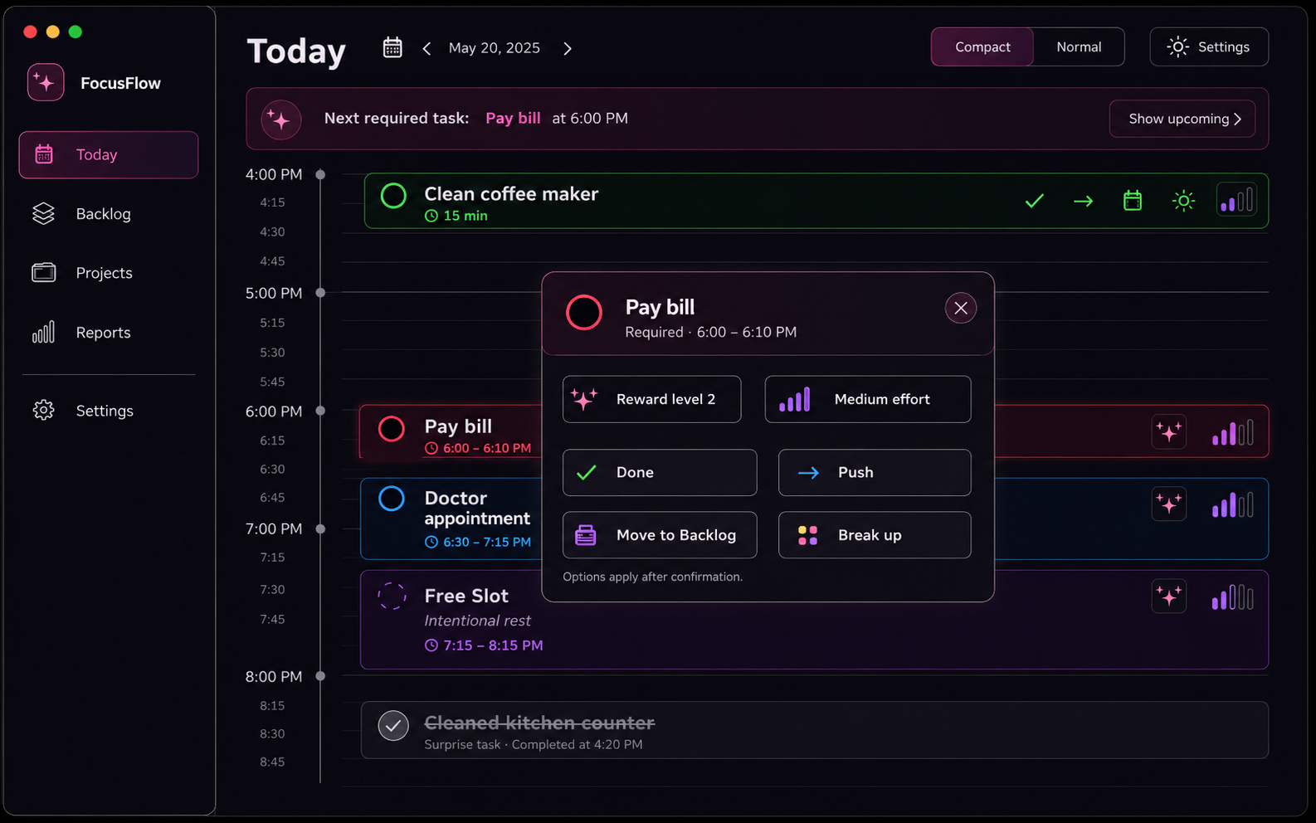
Current implemented interaction: selected-task modal opens from a task card and can be dismissed.
The images show the implemented UI Plan 1 slice. They do not imply that every visible button is wired: the app README states that the current visible controls are intentionally no-op except selecting a task card and closing the modal.

Status legend
Label | Meaning
Complete backend/application/persistence | The current repo contains public API, domain behavior, tests, and/or persistence support for the requirement.
Implemented UI slice | The compact Today screen or selected-task modal renders the concept.
Planned V1 UI wiring | The backend exists, but the user-facing Flutter controls are not fully wired in the current visible slice.
Deferred V2/non-MVP | Explicitly outside V1 per current repo/human spec.

V1 feature requirements
ID | Requirement | Layperson description | Status
R-01 | Quick capture title-only task | User can enter only a title and safely create a task without planning details. | Backend/application complete; planned UI full quick-capture surface.
R-02 | Neutral Backlog defaults | New vague work lands in Backlog with Inbox/Unsorted project, medium priority, and unset reward/difficulty where appropriate. | Complete backend and persistence mapping.
R-03 | Immediate schedule when duration exists | User can ask the app to place a captured/backlog task automatically instead of choosing a precise time. | Backend complete; review UI planned.
R-04 | Today timeline | Today shows work in time order, with task type, project, reward, difficulty, and required/free/hidden context represented calmly. | Read model and compact UI slice complete; broader controls planned.
R-05 | Compact Today mode | A lower-friction Today view can show only the most relevant current/next work. | Backend/read model and current compact screen complete; user toggle command planned.
R-06 | Flexible push actions | Flexible tasks can be pushed to next available slot, tomorrow/top queue, or Backlog. | Backend complete; visible UI actions mostly no-op in current compact slice.
R-07 | Backlog scheduling | Backlog tasks can be inserted into the soonest valid slot while later flexible work moves if needed. | Backend complete; Backlog table/view UI planned.
R-08 | App-open rollover | Unfinished flexible tasks can roll to tomorrow/top queue with a small notice instead of becoming failure noise. | Backend recovery complete; UI notice wiring partially represented.
R-09 | Surprise completed work | User can log something they already did; it occupies actual time and flexible work repairs around it. | Backend complete; UI planned.
R-10 | Child task breakdown | Large tasks can be broken into children with their own priority, reward, and duration. | Backend complete; UI planned.
R-11 | Parent/child completion | Parent completes when children are complete; parent/child force-complete flows exist. | Backend complete; UI planned.
R-12 | Backlog staleness | Old backlog items get ambient markers, not nagging prompt streams. | Backend/read model complete; Backlog UI planned.
R-13 | Stats for future insight | Pushes, misses, completion timing, project patterns, and reminder observations are recorded silently. | Backend/persistence complete; reports deferred.
R-14 | Locked time | Recurring hidden locked blocks and one-day overrides protect unavailable time without cluttering Today by default. | Backend/persistence complete; overlay/reveal UI planned.
R-15 | Critical/inflexible handling | Required commitments stay fixed; missed outcomes are recorded differently for critical vs inflexible tasks. | Backend complete; UI action wiring planned.
R-16 | Free slots | Intentional rest blocks normal flexible placement and suppresses normal flexible reminders. | Backend complete; UI creation/edit planned.
R-17 | Projects and defaults | Projects group work and provide defaults for priority, reward, difficulty, duration, and reminder profile. | Backend/persistence complete; project UI planned.
R-18 | Readable export | User can produce JSON/CSV-style readable data exports. | Library complete; app UI wiring planned.
R-19 | Encrypted backup/restore | User can create/restore encrypted SQLite backups separate from readable export. | Library complete; app UI wiring planned.
R-20 | Desktop notifications | Reminder delivery goes through notification adapters, not core scheduling code. | Contracts and desktop package complete; app scheduling/config UI planned.

Core user flows
Flow | What the user expects | System behavior | Current UI status
Add a new task | Type a title and save without deciding every detail. | Creates a backlog task with neutral defaults. Duration/project/notes can come later. | Backend complete; full drawer UI planned.
Schedule a backlog task | Ask the app to fit the task somewhere soon. | Scheduler finds earliest valid slot, skips locked/required time, shifts later flexible work, or explains no fit. | Backend complete; Backlog/Add/review UI planned.
Edit a scheduled task | Change details without accidentally breaking the day. | Harmless metadata saves directly; duration/type/deadline-style changes route through scheduling review when they affect placement. | Design flow documented; full editor planned.
Move Task A out, schedule Task B in | Replace planned work without losing either task. | Task A becomes Backlog with schedule cleared. Task B schedules through normal earliest-slot rules. | Backend operations exist; full UI flow planned.
Mark work complete | Record done and get the day updated. | Domain command updates status/activity/stat/read-model state. | Backend exists; current visible modal controls mostly no-op by UI Plan 1.
Recover after missed work | Open the app and see what moved without being blamed. | Flexible leftovers roll forward with notices; required missed behavior follows type rules. | Backend recovery complete; notice UI planned.

Task types and human meaning
Task type | Meaning to user | Scheduling behavior
Flexible | Normal work that can move. | Can be pushed, rolled, shifted, or returned to Backlog.
Critical | Required visible commitment that still needs action if missed. | Does not auto-move during flexible scheduling; missed event moves current state to Backlog while preserving missed metadata.
Inflexible | Required time-bound commitment. | Does not auto-move; if missed, remains missed in the original interval as historical context.
Locked | Unavailable time or constraint, usually hidden. | Blocks scheduling; not a normal task card.
Surprise | Unplanned work already completed. | Logged as completed actual occupied time; overlapping flexible work can be repaired.
Free Slot | Intentional rest/protected space. | Blocks automatic flexible placement and suppresses normal flexible reminders.

Task lifecycle states
Status | Plain-language meaning
planned | Work is on the schedule or queued in the plan.
active | Work is currently in progress.
completed | Work is finished.
missed | A required/planned time did not happen and should be recorded calmly.
cancelled | The work was expected but intentionally will not happen.
noLongerRelevant | The work no longer matters because circumstances changed.
backlog | The task is safe but unscheduled.

Pushed and skipped are not durable lifecycle statuses in V1. They are represented as movement/activity/stat metadata.

Today requirements
- Today is the anchor screen for the selected day.
- Timeline cards show scheduled work in time order.
- Flexible tasks show duration and can move.
- Required/locked/protected items stay fixed according to type rules.
- Compact mode reduces visual load by emphasizing current/next work.
- Current UI Plan 1 implements a compact Today visual slice and selected-task modal; full functional controls are planned V1 UI wiring.

Backlog requirements
- Backlog is a safe unified state for unscheduled work, not a failure bucket.
- Quick capture defaults to Backlog unless the user explicitly schedules and duration is known.
- Backlog rows should show title, project, duration when known, priority/reward/difficulty where relevant, and why the task is not scheduled.
- Scheduling from Backlog uses the earliest valid flexible slot; it should not ask the user to manually pick a time first.
- Staleness markers are ambient and should not create a warning stream per task.

Scheduling review requirements
- Preview downstream changes when scheduling affects other tasks, creates risk, or cannot place an item.
- Separate newly scheduled, moved, unable-to-schedule, and at-risk outcomes.
- For moved tasks, show before and after times.
- Cancel must preserve the original list; Apply must commit the selected task and dependent changes as one change set.
- No-fit must keep the task safe in Backlog and explain the blocking constraint.

Data, backup, export, and notification requirements
Capability | Human requirement | Current implementation status
Local persistence | The app remembers tasks, settings, projects, locked blocks, activities, and snapshots locally. | SQLite/Drift adapter exists behind repository contracts.
Encrypted backup/restore | A user can preserve/restore the actual local database securely. | Backup library exists; UI wiring planned.
Readable export/import style data | A user can get data out in readable JSON/CSV-style form. | Export controller and JSON/CSV writers exist; UI wiring planned.
Notifications | The app can eventually remind without putting platform APIs into core. | NotificationAdapter and desktop implementation exist; UX/config wiring planned.
Stats | The app quietly records useful patterns for later suggestions/reports. | Internal stats exist; reports deferred.

Deferred and explicitly not V1
ID | Deferred item | Reason
D-01 | Week/month views | V2/non-MVP.
D-02 | Weekly reports/dashboard | V2/non-MVP; current stats are collected for later.
D-03 | Overwhelm Shield and burnout catch-up | V2/non-MVP, despite older UX deck mentioning future surface.
D-04 | Drag-and-drop reordering | V2/non-MVP.
D-05 | Visible per-task history panel | V2/non-MVP; internal activity records exist.
D-06 | Task dependencies and context tags | Wishlist/non-MVP.
D-07 | Flexible-task overrun behavior | Wishlist/non-MVP decision.
D-08 | Sync/cloud/auth/provider calendars | Not claimed for V1 in repo truth.

Release-readiness checklist for V1 UI
Area | Needed before end-user-complete V1
Quick capture | User-facing create drawer or field wired to quickCaptureToBacklog and optional immediate scheduling.
Backlog | Backlog table/list UI with filters/sorts/staleness and Add action.
Today actions | Done, Push, Move to Backlog, Break up, required task actions, and selected-task modal buttons wired to application commands.
Scheduling review | Review screen/dialog for downstream changes, no-fit, and at-risk items.
Persistence composition | Flutter runtime composition backed by SQLite instead of only seeded in-memory demo data.
Settings/projects/locked time | UI to manage project defaults, compact mode/day settings, and locked blocks/overrides.
Backup/export | User-facing flows for encrypted backup/restore and readable export/import.
Notifications | User-facing configuration and adapter scheduling path.
Validation/errors | Calm, typed error states for validation, conflicts, stale revisions, persistence failures, and recovery notices.

Second-pass accuracy scan
Check | Result
Superseded persistence plans | MongoDB-era material was excluded from current implementation guidance. V1 is documented as SQLite-first with Drift inside the SQLite adapter.
Implemented vs planned labels | Backend/core/persistence/application features are separated from current visible Flutter UI and planned UI wiring.
Subjective claims | Problem statements are grounded in the human product spec. Subjective design preferences are not presented as implemented facts.
Unverified platform claims | No auth, cloud sync, provider-specific calendar integration, or mobile deployment is claimed for V1.
Local validation | The container used to generate this document does not have Dart or Flutter installed, so live commands were not rerun here. Verification history is taken from repo docs, and command instructions are from repo scripts/README.

Document review outcome: V1 Requirements Specification labels WIP and planned items explicitly and avoids filling gaps with imagined product behavior.

